DSA ASSIGNMENT 3

Q1. Write a program to implement strlen() function

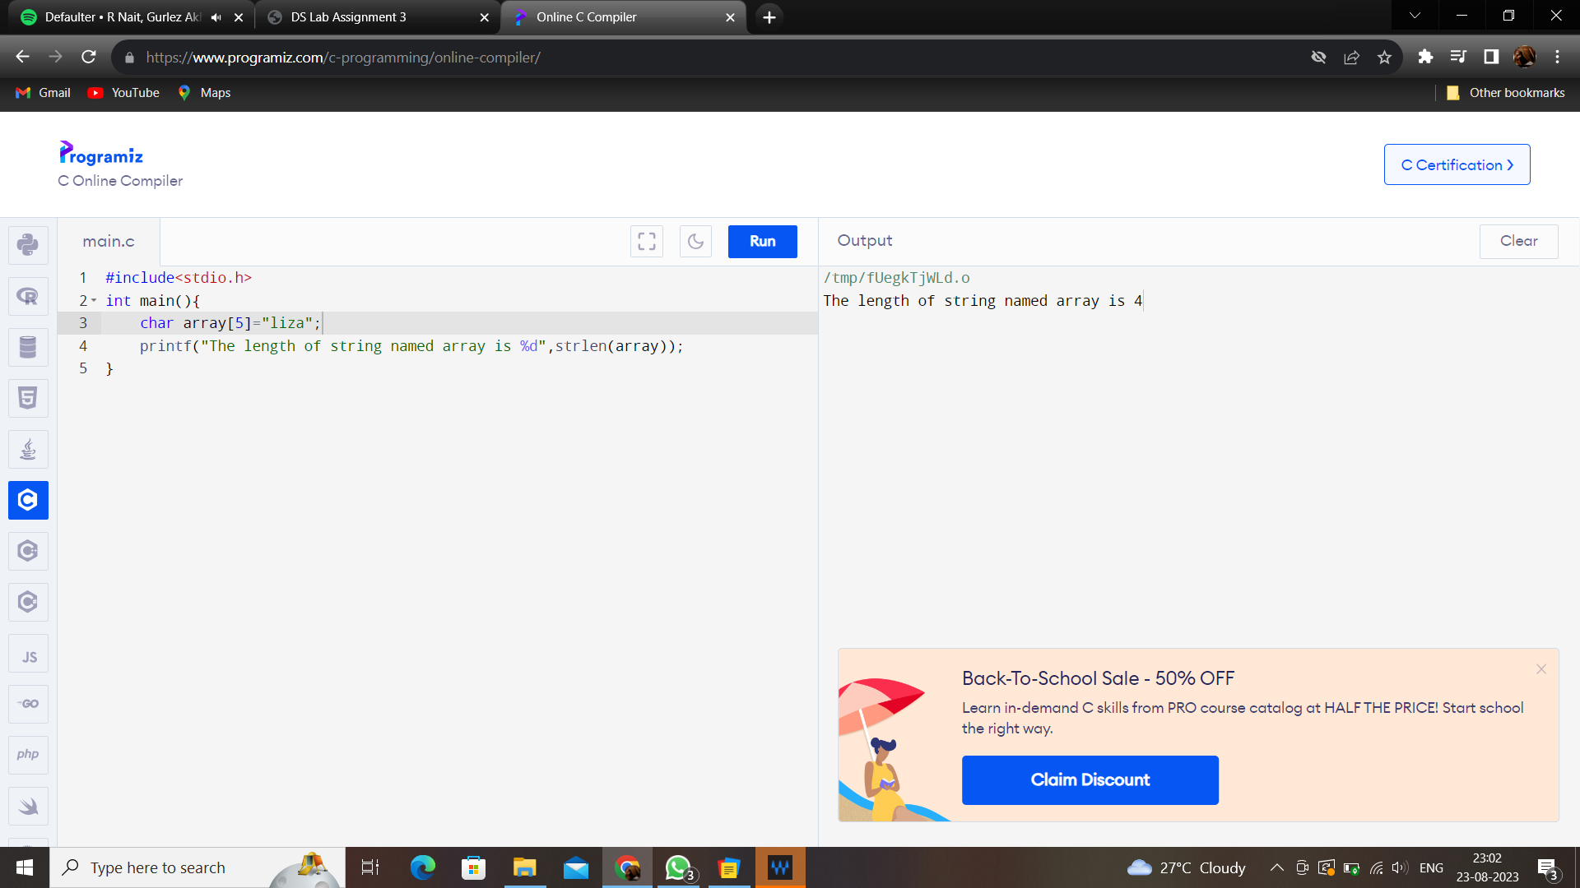

Q2: Write a program to implement strcpy() function.

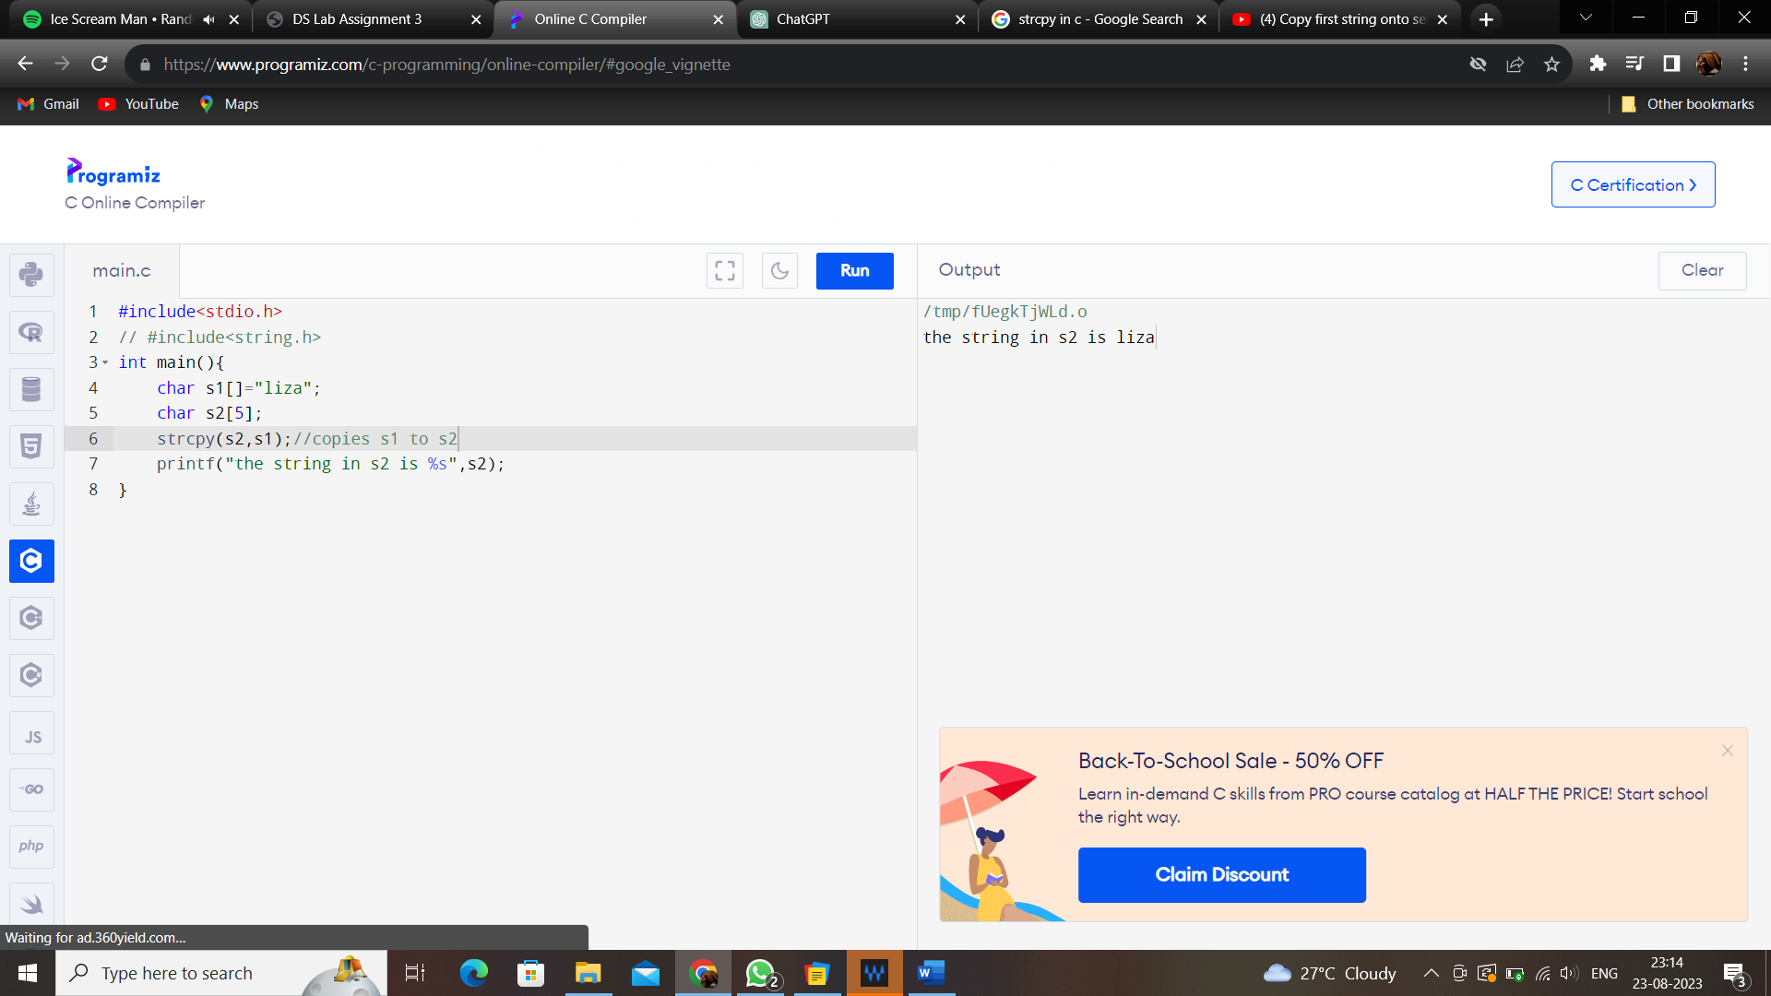

Q3: Write a program to implement strcat() function.

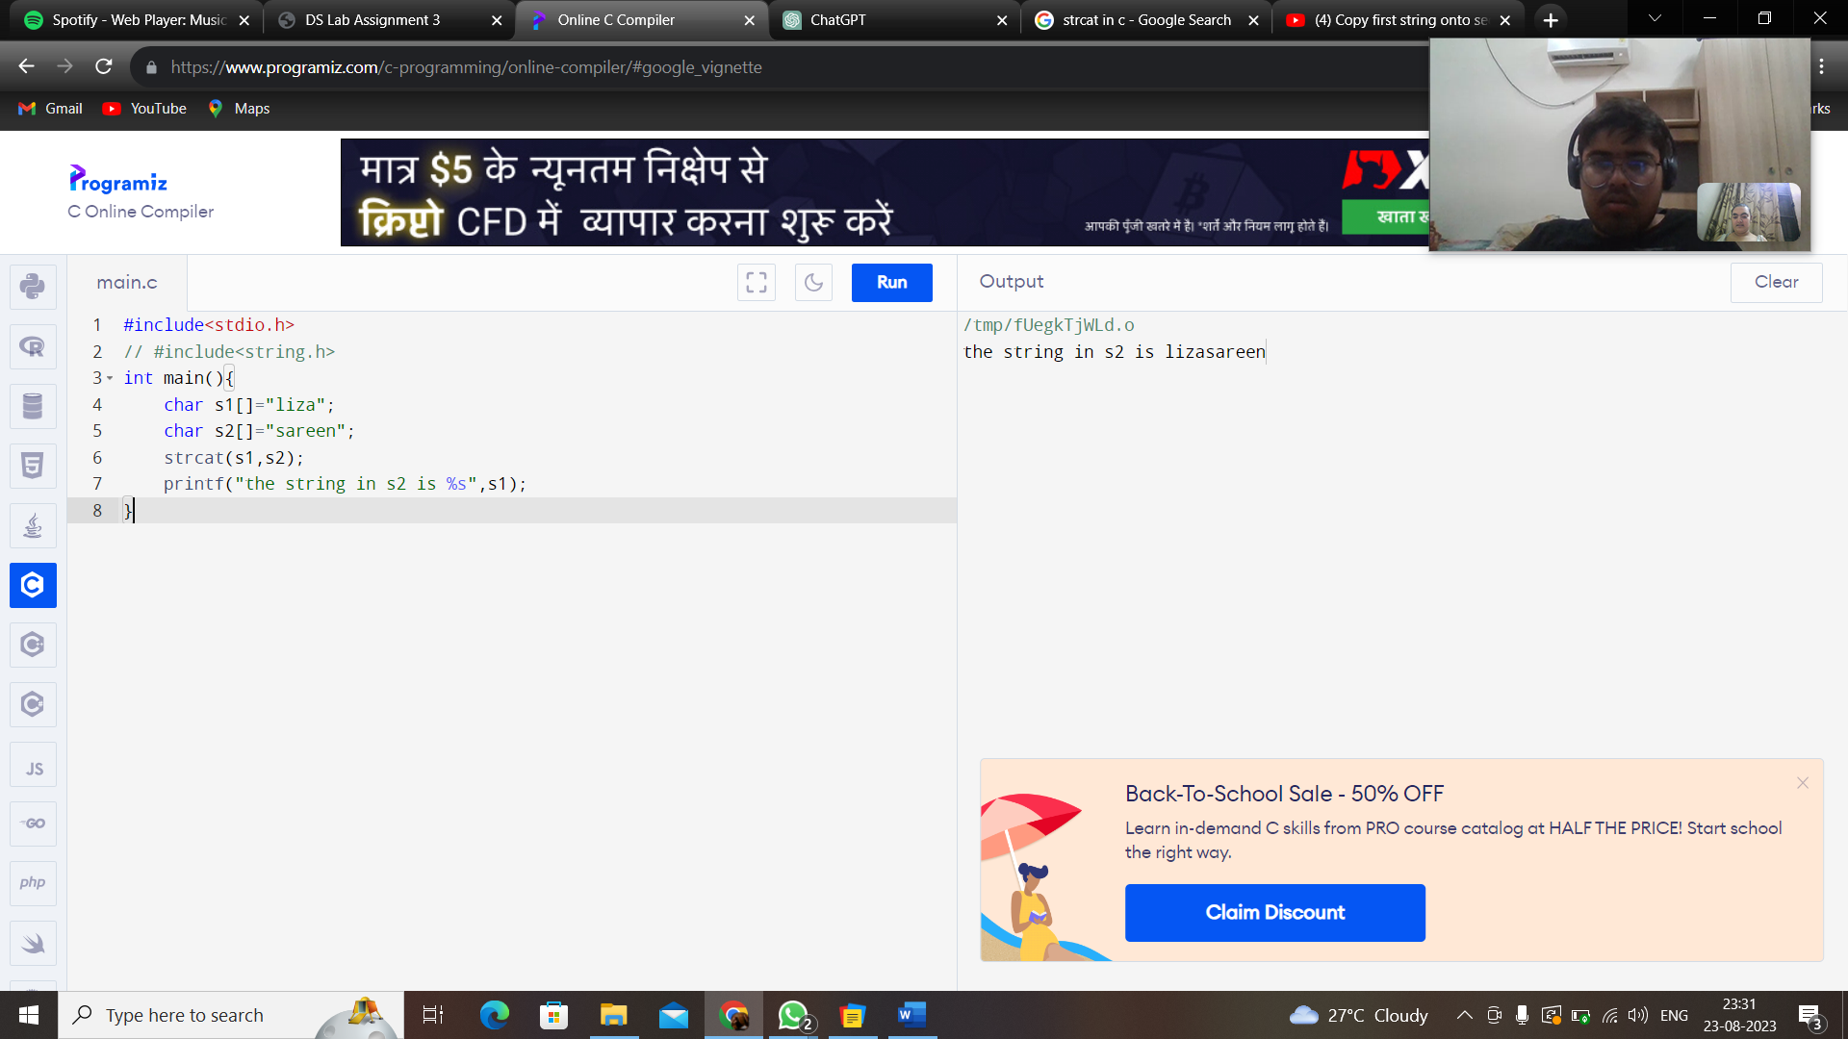

Q4: Write a program to implement strcmp() function

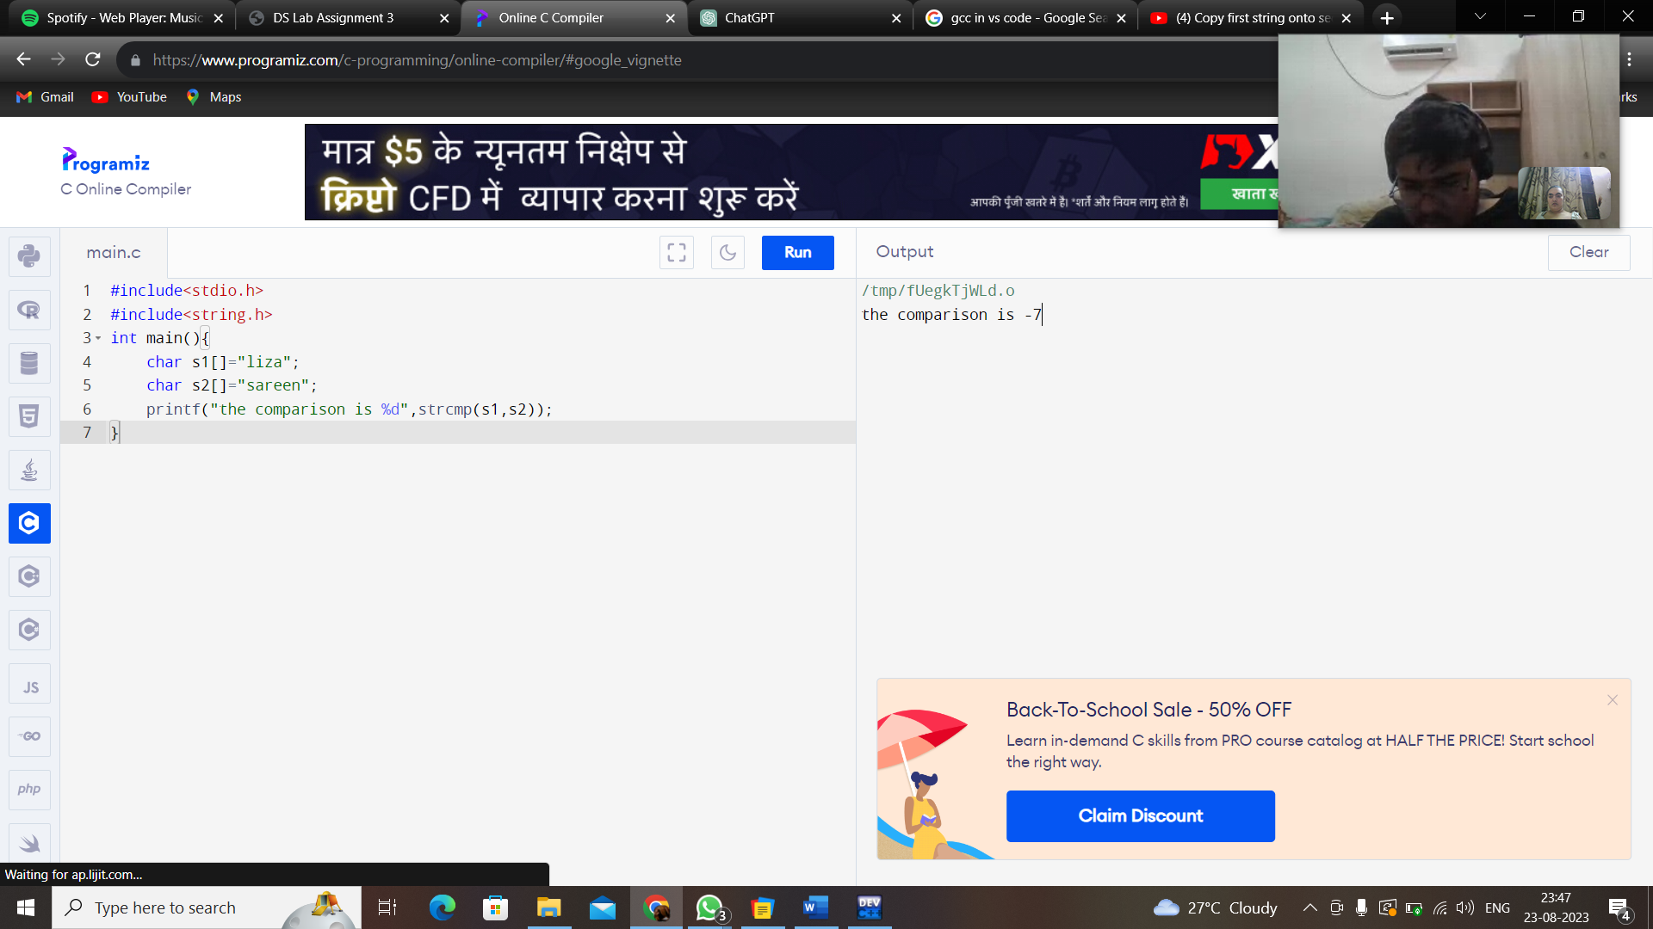

Q5: WAP to demonstrate limitations of Two-Dimensional Array of Characters.

The advantages of array of pointers are :

1. Unlike the two -dimensional array of characters, in pointer array we have variable memory space for elements.
2. The strings occupy only as many bytes as required hence, there is no wastage of space.

Q6: WAP to demonstrate an array of Pointers to Strings

